North Dakota SARE Mini-grant Program
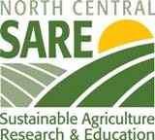
The North Dakota SARE Mini grant Program is a professional development program supported by North Central SARE (Sustainable Agriculture Research and Education) and the NDSU Extension Service.

Program Overview: Sustainable Agriculture is about building the food and fiber systems through integrating goals that enhance quality of life, the environment, and economics. Food productions systems that are likely to remain productive and sustainable are those that meet all three of these major goals.
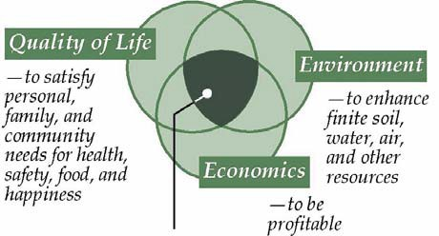
The ND SARE mini-grant program can be used for funding meetings, workshops, tours, webinars, focus groups/ study circles, booth sponsorships, and other learning experiences focused on sustainable agriculture that align with current ND-SARE initiatives.

The 2023-2024 ND SARE initiatives are:
- Soil Health, Cover Crops, and Water Quality
- Local Agriculture Serving Diverse Communities and meeting Nutritional Needs
- Integrated Production Systems – Livestock and Crops
- Advancing Sustainable Agriculture in 1994 Land Grant Colleges and Tribal Institutions
- Adapting to a changing climate and other food system disruptions

For more information about ND SARE initiatives and ideas for programs that fit within the initiatives, please contact one of the ND SARE Coordinators below:

Karl Hoppe, Extension Livestock Systems Specialist
Carrington Research Extension Center, ND 701-652-2951
karl.hoppe@ndsu.edu

Jeff Gale, Agriculture and Natural Resources Extension Agent
Carrington, ND
Jeff.gale@ndsu.edu

Lindy Berg, Agriculture and Natural Resources Extension Agent
Cando, ND (701)968-4362
Lindy.l.berg@ndsu.edu

Part 1 - Application Form -- ND SARE Mini Grant Program

Name:
Position:
Address:
Phone and Email:
Organization:

Section 1: Mini Grant
Proposed Mini Grant Event: ______________________________________________
Date(s):____________________________________
Description of Professional Development Event:
Amount of request: ________________________________________
Please itemize the expense (booth fee, travel expense, sponsorship, speaker fee, etc)

Description of the event:

Do you have other funding resources?
Please itemize requests from other sources

Sections 2: Description of Activity and Learning Outcomes you will conduct

The mini grant requires that you provide a program, meeting and/or event that you will conduct in your county or region as a result of attending the Professional Development event.

Describe the type of program, meeting and/or event that you will conduct as a result of attending the professional development event.

- ND SARE initiative Category: ______________________________(see cover page for initiatives)

- Write a one paragraph description of the activity in your county or region that you will conduct after attending/hosting the professional improvement event. (Be specific and include a program title and description.)

- Write one paragraph on the anticipated learning outcomes from the activity described above. (Please indicate outcomes – examples: 55% of participants changed habits, the event increase $$ per person, improved soil health by an estimated 30%)

Part 2 - Application Form -- ND SARE Mini Grant Program
After the program or meeting conducted, report on the following and re-submit:
*******************************************************************
Educational Program or Event (title): __________________________________________
Please complete the following about the event:
Attendance: (or number participated)
_____ Extension
_____ NRCS
_____ NGO (non-governmental organization
_____ Agency (state, federal or tribal)
_____ Farmer/ Rancher
_____ For-Profit Organization
_____ Other

- Please update the learning outcome paragraph that was previously submitted

